**Chapter 4**

**Design**

1. **Use Case for Cab Transaction using facial recognition**

A use case diagram at its simplest is a representation of a user's interaction with the system that shows the relationship between the user and the different [use cases](https://en.wikipedia.org/wiki/Use_case) in which the user is involved. The use cases are represented by either circles or ellipses.

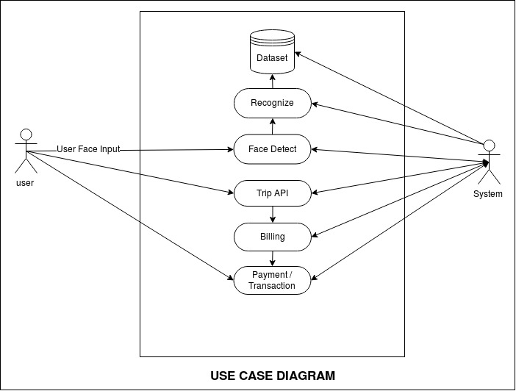

Fig 4.1: Use Case for Cab Transaction using facial recognition

Fig 4.1 explains the overall use case diagrams which are valuable for visualizing the functional requirements of a system that will translate into design choices and development priorities. They also help identify any internal or external factors that may influence the system and should be taken into consideration.

**4.2 Data Flow Diagram for Cab Transaction using facial recognition**

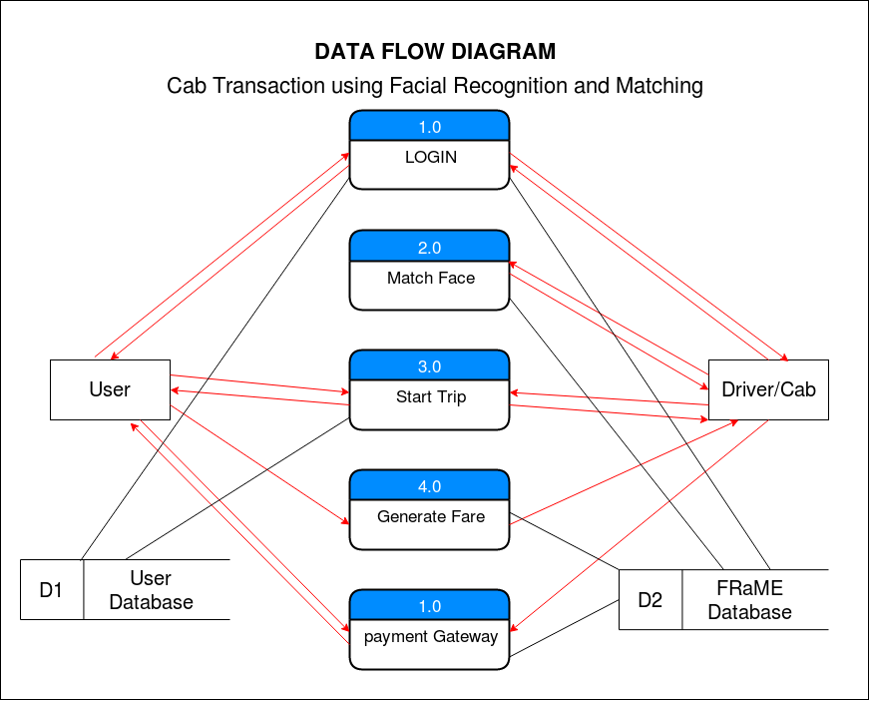A data flow diagram (DFD) is a graphical representation of the "flow" of data through an information system, modelling its process aspects. A DFD is often used as a preliminary step to create an overview of the system without going into great detail, which can later be elaborated.

Fig 4.2: Data Flow Diagram for Cab Transaction using facial recognition

In Fig 4.2 Data flow diagrams can be divided into logical and physical. The logical data flow diagram describes flow of data through a system to perform certain functionality of a business. The physical data flow diagram describes the implementation of the logical data flow. The dataset used by facial recognition also uses the same database in a specific user directory structure. The facial recognition and matching engine consists of two part which are face recognition and matching engine. The Authenticator is one of the most important part of the system, it is the bridge between the webapp and the frame engine, it identifies whether an particular user already exists or not.

1. **Sequence Diagram for Cab Transaction using facial recognition**

A sequence diagram simply depicts interaction between objects in a sequential order i.e. the order in which these interactions take place. System can also use the terms event diagram**s** or event scenarios to refer to a sequence diagram. Sequence diagrams describe how and in what order the objects in a system function.

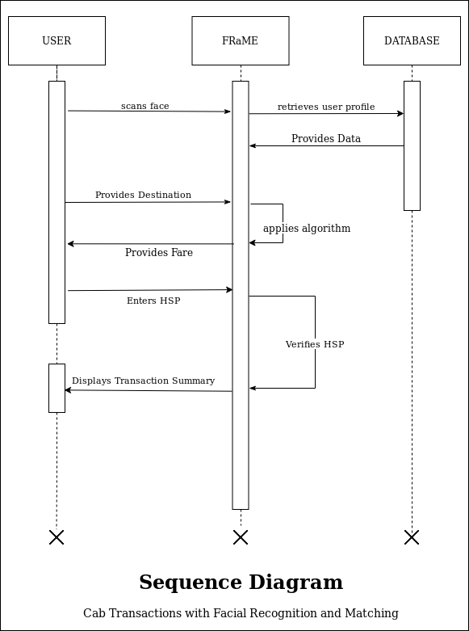

Fig 4.3: Sequence Diagram for Cab Transaction using facial recognition

In Fig 4.3 sequence diagram shows, as parallel vertical lines (lifelines), different processes or objects that live simultaneously, and, as horizontal arrows, the messages exchanged between them, in the order in which they occur. This allows the specification of simple runtime scenarios in a graphical manner. The dataset used by facial recognition also uses the same database in a specific user directory structure. The facial recognition and matching engine consists of two part which are face recognition and matching engine. The Authenticator is one of the most important part of the system, it is the bridge between the webapp and the frame engine, it identifies whether an particular user already exists or not.

1. **Activity Diagram for Cab Transaction using facial recognition**

Activity diagram is a flow chart to represent the flow form one activity to another activity. The activity can be described as an operation of the system. The control flow is drawn from one operation to another.

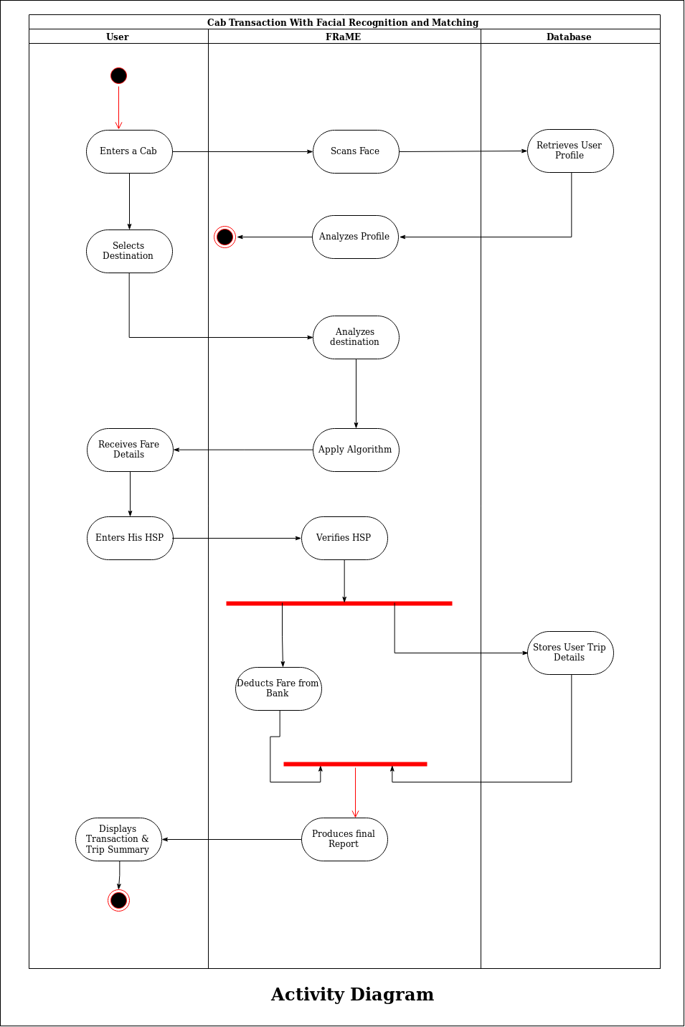

Fig 4.4: Activity Diagram for Cab Transaction using facial recognition

This flow can be sequential, branched, or concurrent. Activity diagrams deal with all type of flow control by using different elements such as fork, join, etc. Fig 4.4 shows the activity diagram for Cab Transaction using Facial Recognition and matching that shows the flow of activity from the different components of the system.